Cyber Crime and Digital Evidence
Report Writing



Submitted by:
Full Name: Anish Adhikari
Orbund ID : 11147
Student ID : 24071101
Kathmandu, Nepal

TABLE OF CONTENTS

1. Introduction .................................................................................................................... 3
1.1 Case Overview and Request .................................................................................. 3
1.2 Analyst’s Relevant Experience ............................................................................. 3
2. Evidence Summary ...................................................................................................... 4
2.1 Description of Digital Evidence Items ................................................................... 4
2.2 Unique Identifiers ................................................................................................... 4
2.3 Evidence Provenance and Condition ...................................................................... 5
3. Examination Summary ............................................................................................... 6
3.1 Overview of Critical Findings and Conclusions ..................................................... 6
3.2 Tools Used .............................................................................................................. 6
3.3 Elimination of Irrelevant Data ................................................................................ 7
4. Forensic Analysis and Findings ................................................................................ 8
4.1 User and System Profiling ...................................................................................... 8
4.2 File System and File Signature Analysis ............................................................... 12
4.3 Image Analysis ....................................................................................................... 14
4.4 Internet Activity ..................................................................................................... 17
4.5 Email and Messaging Activity ............................................................................... 19
4.6 Disc Wiping Activity .............................................................................................. 23
4.7 External Devices and Removable Media ............................................................... 25
5. Conclusions ..................................................................................................................... 26
6. Glossary of Terms ......................................................................................................... 27
7. Appendix .......................................................................................................................... 28

1. Introduction

1.1 Case Overview and Request
This report summarizes the conclusion of a forensic analysis on case evidence of Bob Hunter, user of Hunter XP disk image. As per the request of University of the West of England (UWE), I examined the suspect's computer looking for the signs of criminal activities or any misconduct.
The evidential media in this case was Hunter XP disk image which possibly consisted of digital footprints confirming the usage of the system. The goal was to confirm the offences via the system based on the digital artifacts.

1.2 Analyst's Relevant Experience
The report along with the examination was prepared by Anish Adhikari, studying for a bachelor’s degree in Cybersecurity and Digital Forensics. Despite being part of academic coursework, this analysis strictly followed the procedure of digital forensics with standard reporting.
Furthermore, the analyst has formal training in evidence handling, file system analysis, timeline reconstruction, as well as handling professional forensics tools.

2. Evidence Summary

2.1 Description of Digital Evidence Items
The digital evidence examined in this case consisted of a forensic disk image named “Hunter XP for Dongled v6.E01”. The image represents a system running the Microsoft Windows XP operating system and was provided in EnCase Evidence File (.E01) format.
Fig 2.1.1 : Hunter Xp Image file
2.2 Unique Identifiers
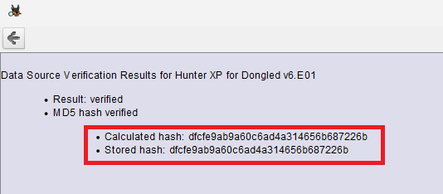
In the initial phase of investigation, cryptographic hash verification was practiced so that the investigation evidence remained authentic. After generating the MD5 hash value of evidence file it got verified in Autopsy before any analysis then after completion of analysis, the value was recalculated reusing the same tool and comparing with original hash value.
Fig 2.2.1: MD5 verified Hash Value

MD5 hash value: dfcfe9ab9a60c6ad4a314656b687226b
MD5 verified hash value: dfcfe9ab9a60c6ad4a314656b687226b
The matching hash values obtained before and after the investigation confirmed that the evidence file remained unaltered throughout the examination process.

2.3 Evidence Provenance and Condition
The reported image was intact with integrity hence no sign of manipulation and inconvenience was discovered. To ensure the accuracy of the analysis, the image was directly loaded into Autopsy as it was automated in read-only manner.
All the recorded data during examination were stored safely on the analyst's personal computer and the protocol of examination was strictly followed in accordance with forensic guidelines to qualify it for academic investigation.

3. Examination Summary

3.1 Overview of Critical Findings and Conclusions
This report outlines the investigation conducted on a Microsoft Windows XP disk image named “Hunter XP" which belonged to the suspect Bob Hunter who was accused of stalking, blackmailing and manipulation. The main objective of this finding was to identify, retrieve and record the relevant details of the crime and to verify the usage of the system in that offence.
During the procedure, email artifacts were recovered which directly linked Bob to the crime. The extortion related communication with metadata, search engines with blackmail tactics, methods of stalking and ways to fabricate the evidence strongly corresponded the forethought planning of the accused committing the sin.
Multiple photographs were discovered confirming secret spying and stalking acts. The blackmailed text messages with bank details further suggested the extortion of money from the victims' families. During investigation, an individual named Billy was identified as an accomplice of Bob. The exchanged messages and emails revealed cooperation and coordination between them to execute the crime.
Additionally, forensic analysis detected signs of CD burning software with data erasing tools that suggested attempts to tamper the evidence. The files showed irregular signatures which corroborated the possible manipulation. Furthermore, the system data and profile information verified that the system was frequently employed even during the relevant period.
Therefore, based on the resources , Bob Hunter is expected to be guilty. He along with his helper Billy misused the system to stalk, conspire and extort the victims. Hence, the acquired details matched the charges against him.

3.2 Tools Used
The following table outlines the forensic tools used during the examination, along with their respective versions and purposes.
Tool Name | Version | Purpose
Autopsy | 4.22.1 | Open-source tool used to analyze the disc image.
Exterro FTK Imager | 7.7.3.81 | Tool used to analyze the disc image.
AccessData Registry Viewer | 2.0.0.7 | Used to examine content of the Registry File.
RegRipper | 3.0 | Used to examine content of the Registry File.
Event Log Explorer | 5.7 | Used to analyze Windows system, security, and application event logs.
Parrot OS | 6.4 | Operating System used to run Ophcrack.
Ophcrack | 3.8.0 | Used to recover password hashes to identify weak or reused passwords.
PECmd | 1.5.0.0 | Used to read the content of prefetch file

3.3 Elimination of Irrelevant Data
During investigation, various data were retrieved from which irrelevant data were identified and later excluded. Default Windows XP system files, background operating system processes, and built-in accounts that were not associated with the crime were disregarded to increase the efficiency of investigation. Duplicated and repetitive data were reviewed and were reduced to single one to reduce cognitive overload. Eliminating outdated files logs and data unrelated to the crime assured accuracy by recording only substantial information to testify direct evidence.

4. Forensic Analysis and Findings

4.1 System Profiling and User Information
The user's Operating System appeared to be Microsoft Windows XP. It was installed on February 28, 2002, at 22:02:39 GMT. Additional information about the system is listed on the table below.
Operating System Information
Name | PC-V770KUX75EHT
Program Name | Microsoft Windows XP
Processor Architecture | x86
Product ID | 55277-005-6418583-21673
Owner | PC User
Organization | PC User Company
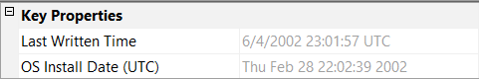
Fig 4.1.1 : Operating System Installation Date
The system operated under Central Daylight Time during daylight saving periods and Central Standard Time during standard periods. The time zone bias was set to 360 minutes (6 hours), with an active time bias of 300 minutes (5 hours) when daylight saving time was in effect.
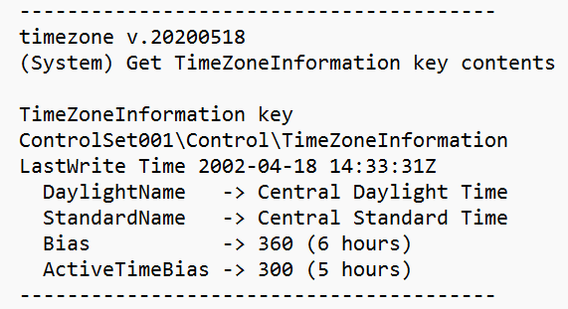
Fig 4.1.2: Time zone Information

The system was last shut down on June 4, 2002, at 22:58:42Z.
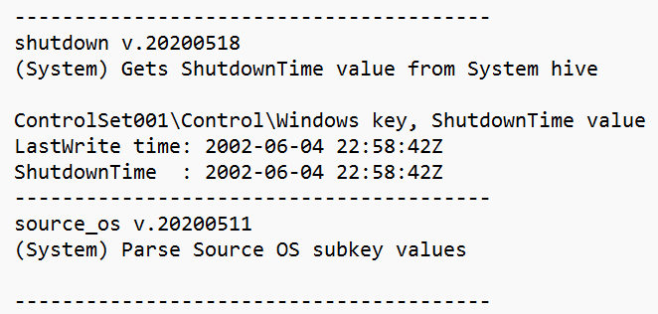Fig 4.1.3: Last Shutdown Time

The Operating System was found to have 5 user accounts in total, including both built-in and user-created accounts. Most of the activity was performed by the user Bob Hunter, with RID 1004.
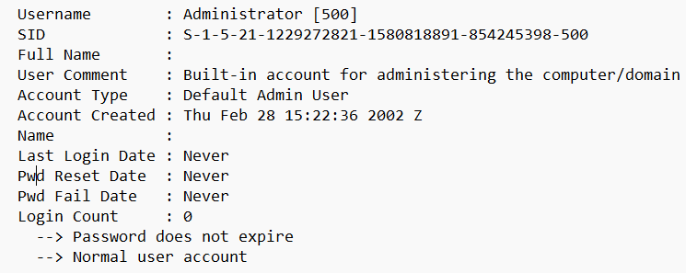Fig 4.1.4: Account information associated with RID 500
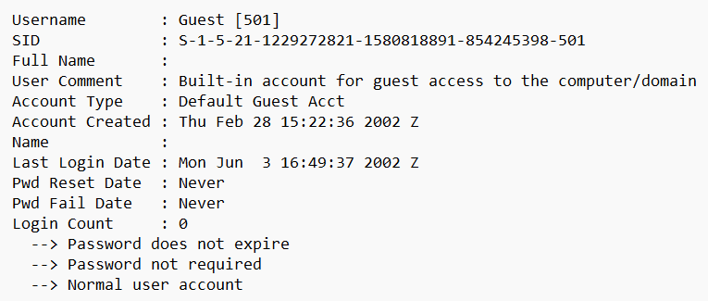Fig 4.1.5 : Account information associated with RID 501
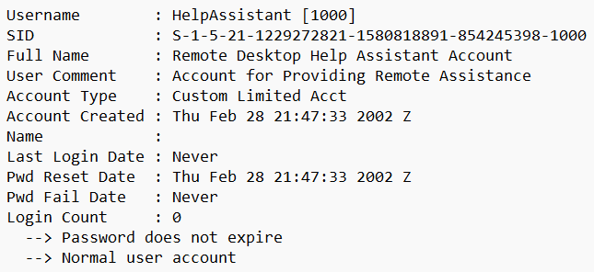Fig 4.1.6 : Account information associated with RID 1000

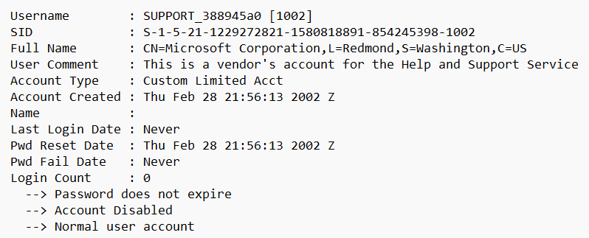Fig 4.1.7: Account information associated with RID 1002

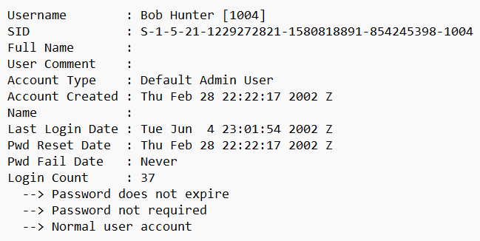Fig 4.1.8: Account information associated with RID 1004

The user account with RID 1003 was missing. The SecEvent.Evt file showed that the user account with the username "Owner" and RID 1003 had been deleted.
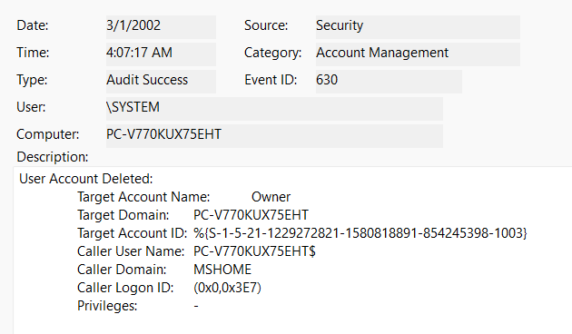
Fig 4.1.9: Deletion of the User Account name “Owner” with RID 1003

4.2 File System and File Signature Analysis
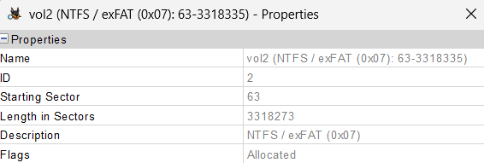
The file system of the examined volume (vol2) was identified as NTFS, as confirmed by volume metadata and the presence of NTFS system files.
Fig 4.2.1 : Properties of vol2

There are total of 58 files with extension mismatch detected.
There were multiple files with different extensions, for instance there is a file named “wbkC1.tmp” with .tmp extension but is a jpeg file.
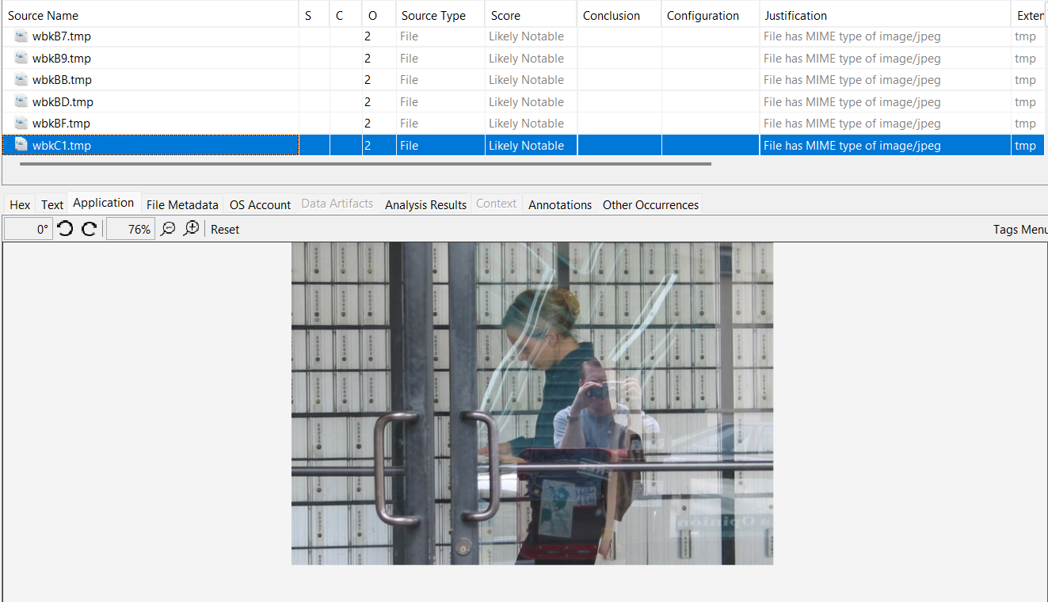Fig 4.2.2: JPEG file with .tmp extension
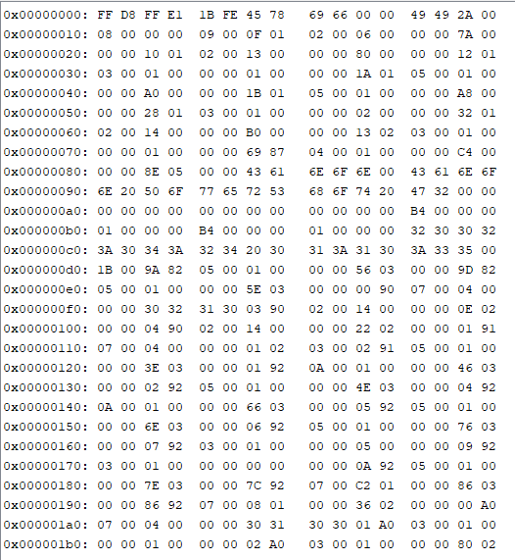
Upon viewing the Hexadecimal value, we can see that it starts with header FF D8 FF which indicates it is a jpeg file.
Fig 4.2.3 : Hexadecimal output of wbkC1.tmp file

4.3 Image Analysis
The images were in the directory:
/img_Hunter XP for Dongled v6.E01/vol_vol2/Documents and Settings/Bob Hunter/Local Settings/Application Data/Microsoft/Cd Burning/Hunter Pics/
Inside this directory, the images were sorted into three separate subfolders according to their respective names:
- Christina Detsiwt – held images associated with the victim Christina Dewist
- Sabrina Dewercs – held images associated with the victim Sabrina Dewercs
- Sabrina and Christina – held images featuring both victims together
The collection included 115 images of Christina Detsiwt stored in her respective folder, 49 images of Sabrina Dewercs in her folder, and 11 photographs showing both Sabrina and Christina together in their combined folder.
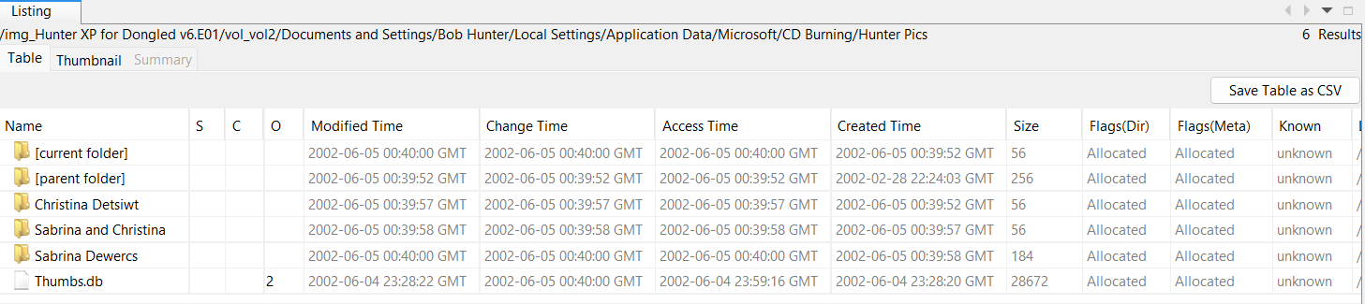Fig 4.3.1 : Folder with the name of Victim’s

The following photographs were from the above-mentioned folders:
Fig 4.3.2 : Picture of Christina Detsiwt
The above-mentioned photograph is from the Folder Christina Detsiwt and consists total of 115 images of Christina.


Fig 4.3.3: Picture of Sabrina and Christina

The above-mentioned photograph is from the folder Sabrina and Christina and is part of a collection of 11 images of both of them together.
The below-mentioned photograph is from the folder Sabrina Dewercs and is part of a collection of 49 images of Sabrina.
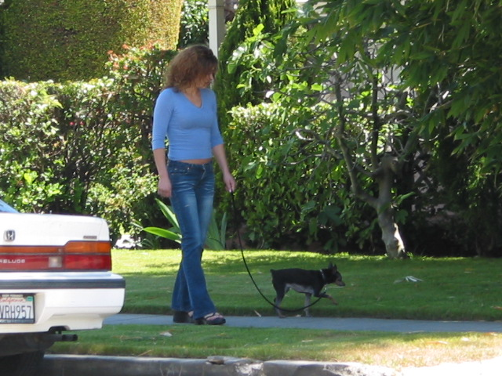
Fig 4.3.4: Picture of Sabrina Dewercs

The images included photographs showing the victim’s daily activities and other content relevant to the stalking allegations. The images show that the photo was taken without the victim’s consent.
Deleted and Recovered Images:
A significant number of images were deleted by the user, as evidenced by their recovery from the Recycler. Forensic recovery techniques allowed retrieval of these deleted files from both the Recycler and unallocated space, indicating that the suspect attempted to remove incriminating evidence.

Location of RECYCLER: /img_Hunter XP for Dongled v6.E01/vol_vol2/RECYCLER

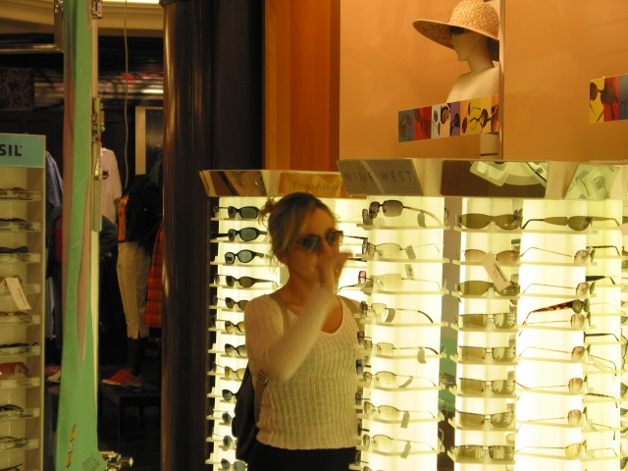
Fig 4.3.5: Image from RECYCLER


Fig 4.3.6: Image from RECYCLER

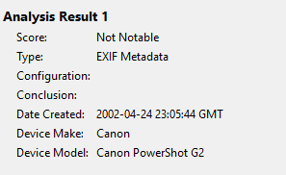
The camera that was used to capture these images was Canon PowerShot G2 as the photos were analyzed, all had same analysis result.
Fig 4.3.7 : Analysis Result

4.4 Internet Activity
The Web Browsers Installed on the suspect's PC were:
- Internet Explorer
- Microsoft Edge
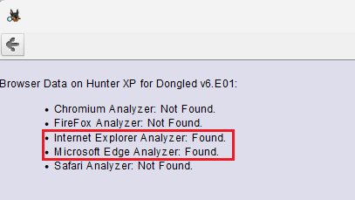
The suspect primarily used Internet Explorer for web browsing. Although Microsoft Edge was installed on the system, there was little to no evidence indicating regular use.
Fig 4.4.1 : Proof of Installation of Internet Explorer and Microsoft Edge

The suspect had bookmarked a total of 16 websites, suggesting regular use of these sites as part of daily internet activity.
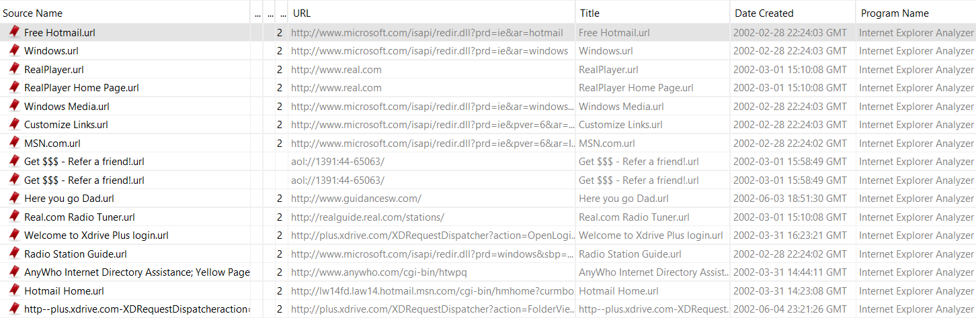
Fig 4.4.2 : Suspect web bookmarks

The suspect utilized the website http://www.guidancesw.com to blackmail the father of Christina and Sabrina. The webpage used for this blackmailing activity is presented below.
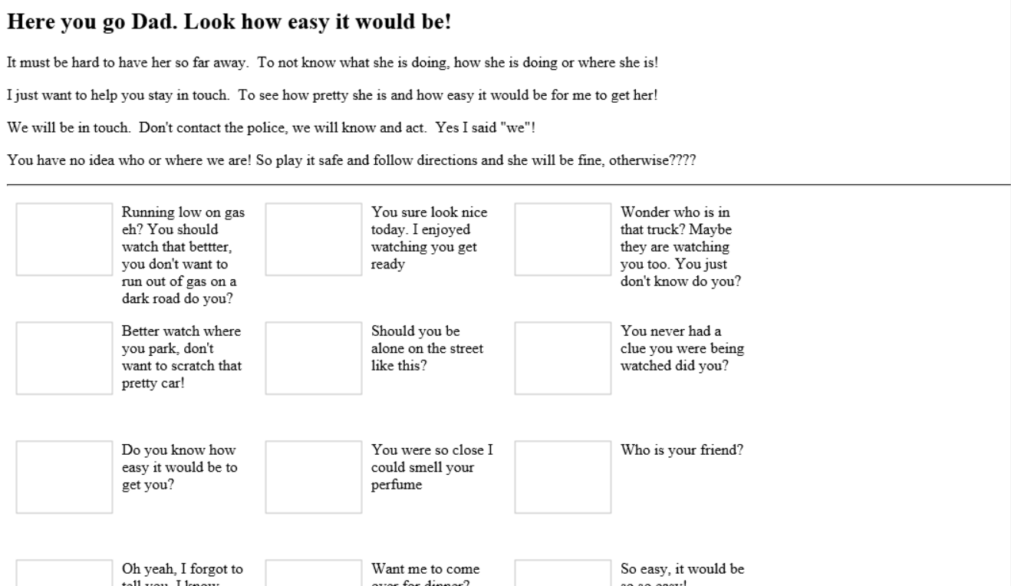
Fig 4.4.3 : Interface of the blackmailing website

Xdrive is an online storage platform. The user bookmarked the website xdrive.com and visited it repeatedly over several days, which suggested that data may have been stored on the service.
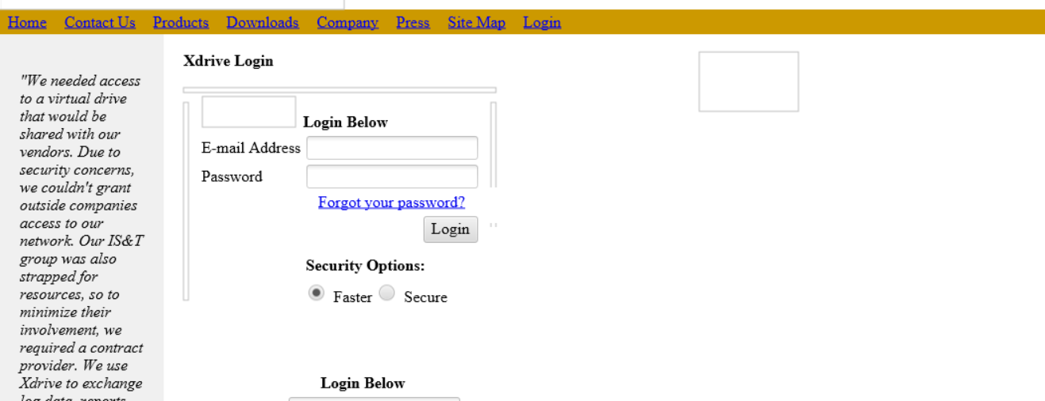
Fig 4.4.4 : Login page of Xdrive

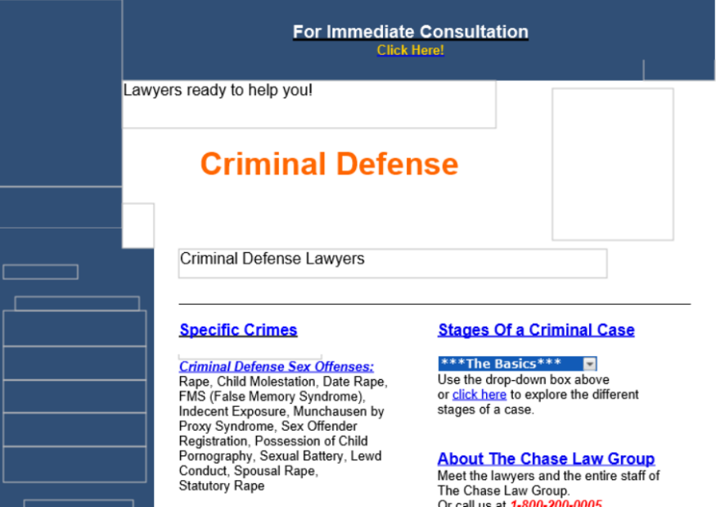
A review of the user's web activity revealed that the user had searched for Criminal Defense Lawyers.
Fig 4.4.5 : Criminal Defense Lawyers website

4.5 Messaging and Email Activity
There was extensive messaging interaction between the user Bob Hunter and a partner named Billy. Initially, the exchanges between Bob and Billy revealed that Bob informed Billy he had been following two girls and knew where they lived.
Chaser1191 = Bob Hunter
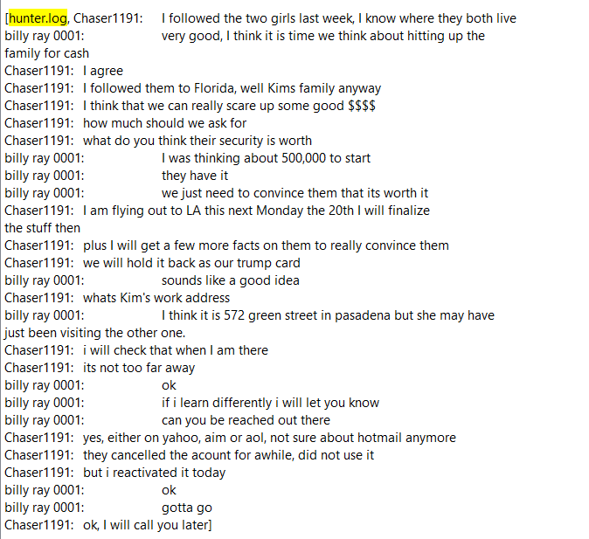
billy ray 0001 = Billy Ray
Fig 4.5.1 : Conversation between Bob and Billy

High levels of communication were observed between two email addresses: chaser1191@hotmail.com and billyray150@hotmail.com. The address chaser1191@hotmail.com was identified as belonging to the primary suspect, Bob Hunter, while billyray150@hotmail.com was believed to belong to his associate or accomplice.

In the content below, it was evident that the accomplice Billy Ray had identified the email addresses of the father of Sabrina and Christina.
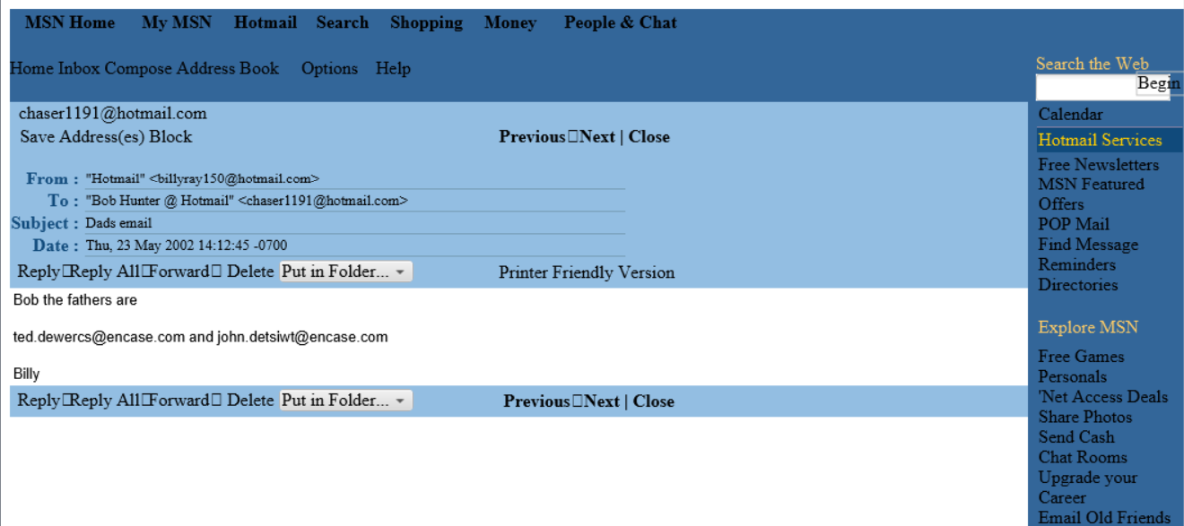Fig 4.5.2: Email addresses of victim’s father

Below is the threatening message that appeared to have been sent to the respective fathers.
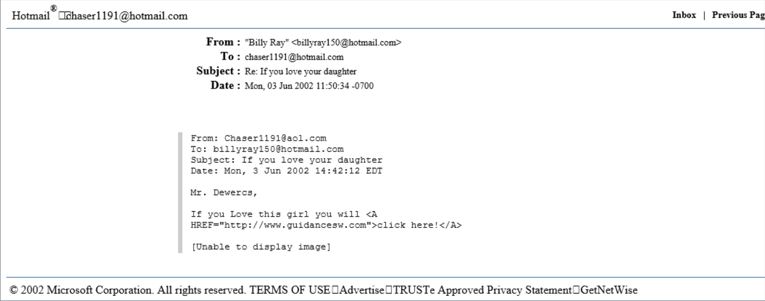Fig 4.5.3: Threating message sent to the victim’s father
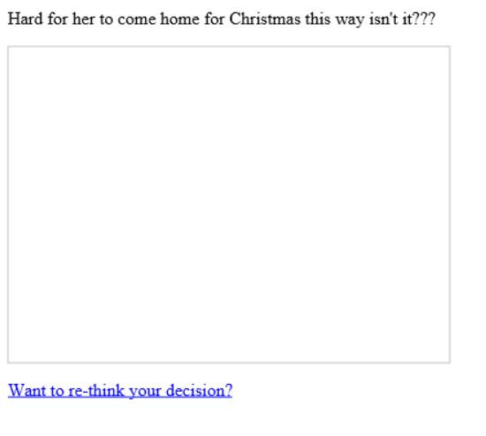

Fig 4.5.4 : Blackmailing

The ransom demand total of 1 million dollars each, and information about the bank routing number and account number was required to ensure the girls' safety.
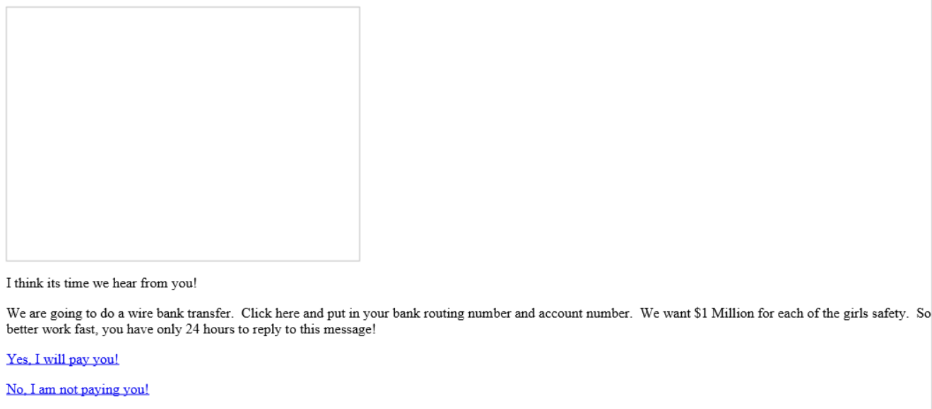Fig 4.5.5 : Bank information asked by the Bob Hunter to victim’s father

Ted Dewercs replied by saying that they were joking but John Detsiwt provided his bank routing number and account number.
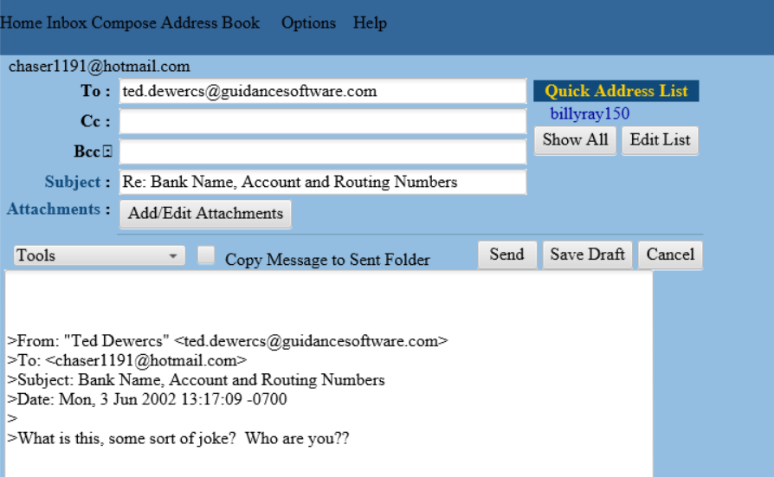
Fig 4.5.6 : Reply of Ted Dewercs

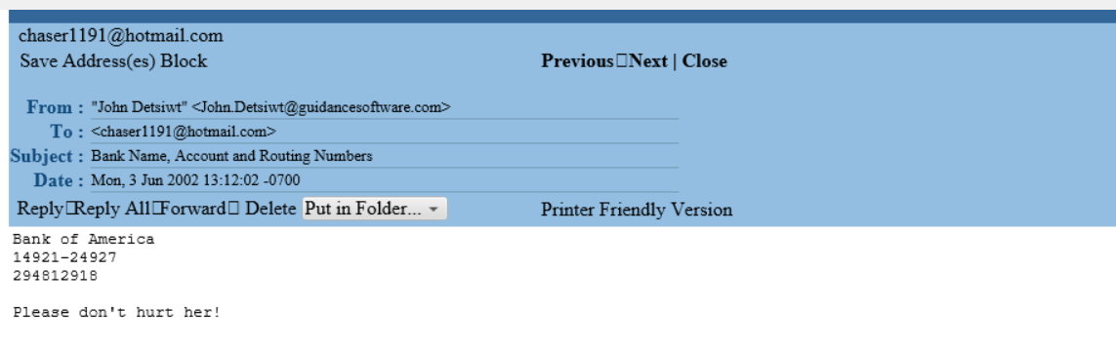Fig 4.5.7 : Reply of John Detsiwt

4.6 Disc Wiping Activities
The executable CLEANMGR.EXE was used to free up disk space by locating and deleting unnecessary files from the system. It was last run on June 3, 2002, at 17:08:40 GMT.
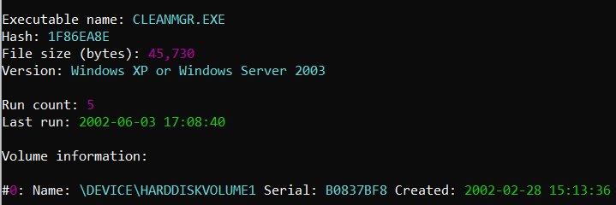
Fig 4.6.1: Content of CLEANMGR.EXE-1F86EA8E.pf with PECMD

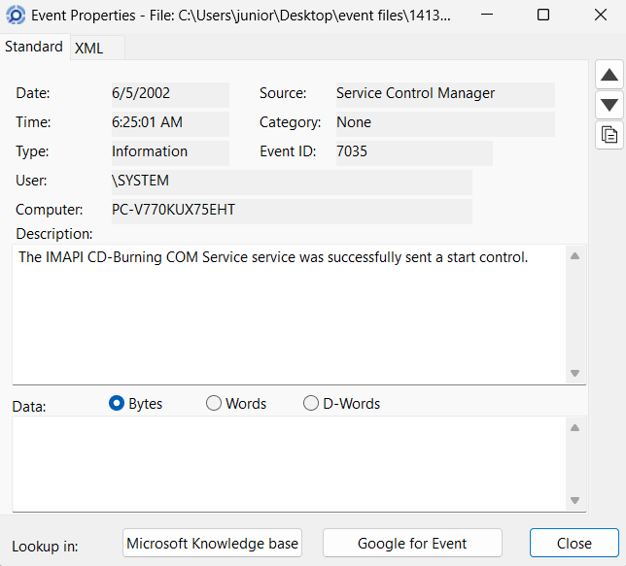
IMAPI.EXE enabled applications to write data and audio onto optical media like CDs and DVDs. Since IMAPI.EXE was the last program run on the PC, this indicated that the suspect was likely attempting to tamper with data and destroy evidence. It was last run on 2002-06-05 00:40:01 GMT.
Fig 4.6.2: log content showing running of IMAPI.EXE
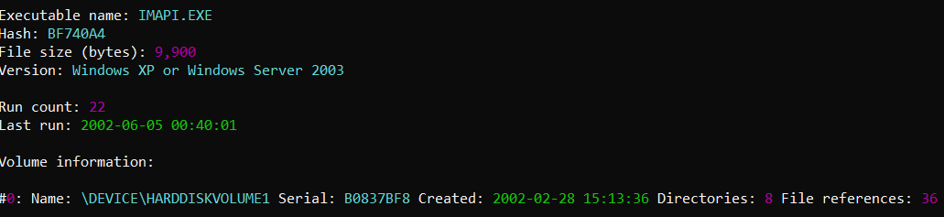Fig 4.6.3: Content of IMAPI.EXE-0BF740A4.pf with PECmd
4.7 External Devices and Removable Media
There were total of 11 USB devices that were attached to the device to the devices. The system was attached to 2 printers, 1 mouse, 1 video capture device, 1 PDA, 2 storage devices, and 4 root/USB hubs.
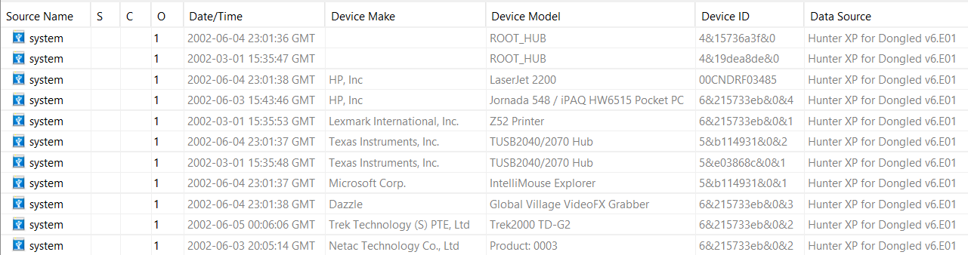
Fig 4.7.1 : Attached USB Devices
I found evidence of a primary hard drive, a floppy disk drive, and two different optical disc drives. I also discovered that several removable storage devices were plugged into the system between February and June 2002.
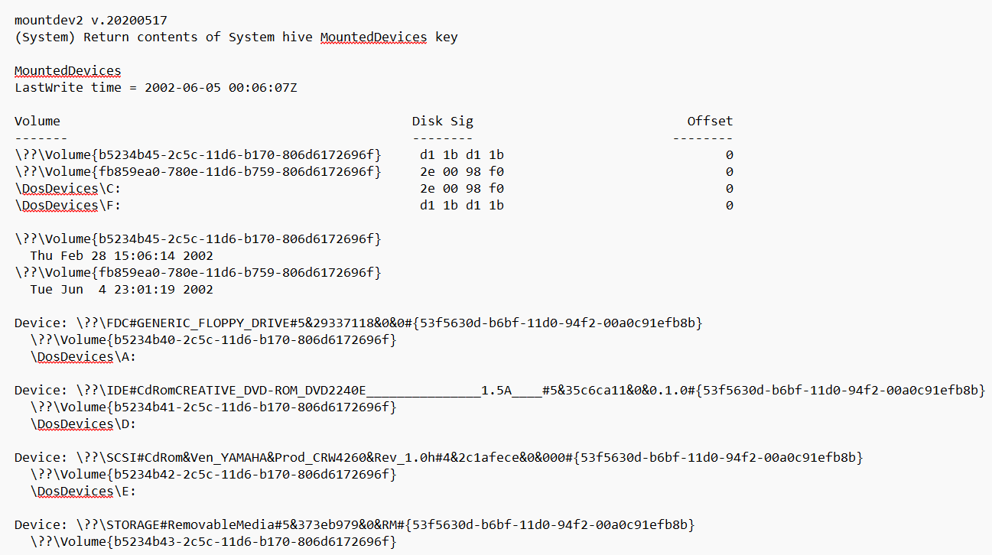
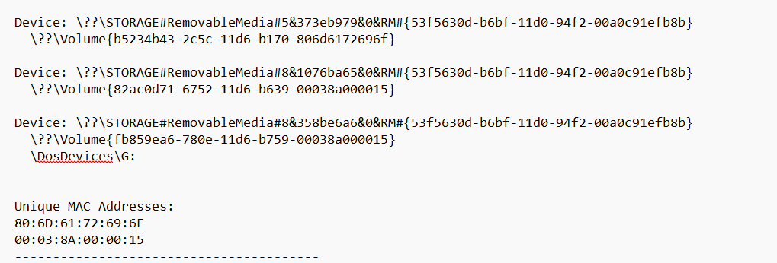
Fig 4.7.2 : Mounted Devices

5. Conclusion

This forensic examination was carried out to identify any unauthorized or criminal activity performed using the examined computer system. Based on the analysis of the available digital evidence, several significant findings were identified.
The recovered artefacts show that the suspect actively used the system to carry out repeated actions related to stalking, harassment, blackmail, and attempts to interfere with or conceal evidence. These findings were supported by user account activity, file system data, image files, internet usage records, and system artefacts recovered during the examination.
All analysis was conducted using accepted digital forensic tools and methods. The integrity of the evidence was maintained throughout the examination process, and hash values were used to ensure that the data was not altered during analysis.
Based on the totality of the digital forensic evidence examined, in my professional opinion, to a reasonable degree of forensic certainty, that the suspect knowingly and intentionally engaged in the identified activities using the examined system. This conclusion is based solely on the evidence that was provided for analysis.

6. Glossary of Terms

- Autopsy: An open-source digital forensic platform used for analyzing and investigating data.
- EnCase Evidence File: A forensic file format used to store an exact, verified copy of digital evidence.
- Cryptographic Hash Verification: The process of confirming that digital data has not been altered by comparing hash values.
- Extortion: The act of obtaining money or advantage through threats.
- Metadata: Data that provides information about other data, such as time, date, and file details.
- CD Burning: The process of writing or copying data onto a CD.
- NTFS (New Technology File System): A file system used by Windows to store and organize files on a hard drive.
- Unallocated Space: Areas of a storage device that are not currently assigned to any file or folder.
- CLEANMGR.EXE: A Windows utility that frees up disk space by removing unnecessary files.
- IMAPI.EXE: A Windows process that handles CD/DVD burning.
- Mounted Device: A storage device that has been connected and made accessible by the operating system.

7. APPENDIX

Metadata of the Images:

- Fig 4.3.2: Picture of Christina Detsiwt
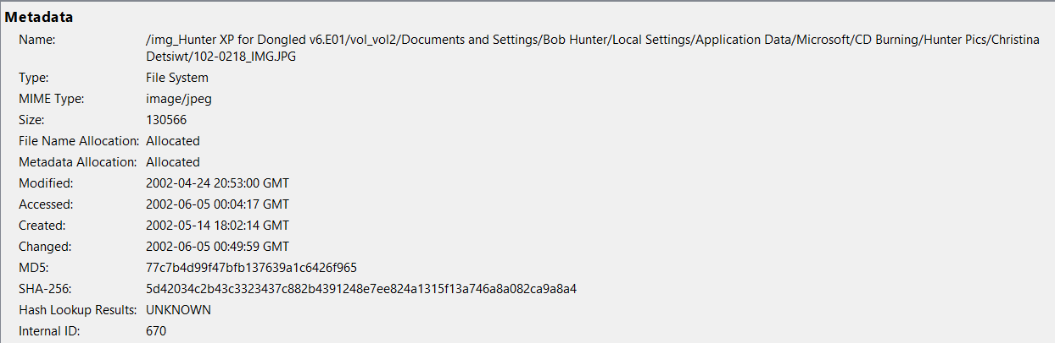

- Fig 4.3.3: Picture of Sabrina and Christina
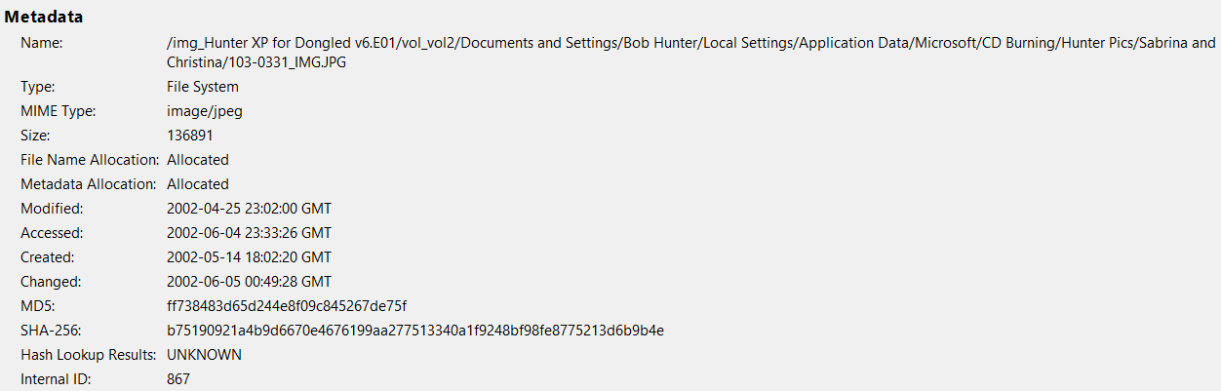

- Fig 4.3.4: Picture of Sabrina Dewercs
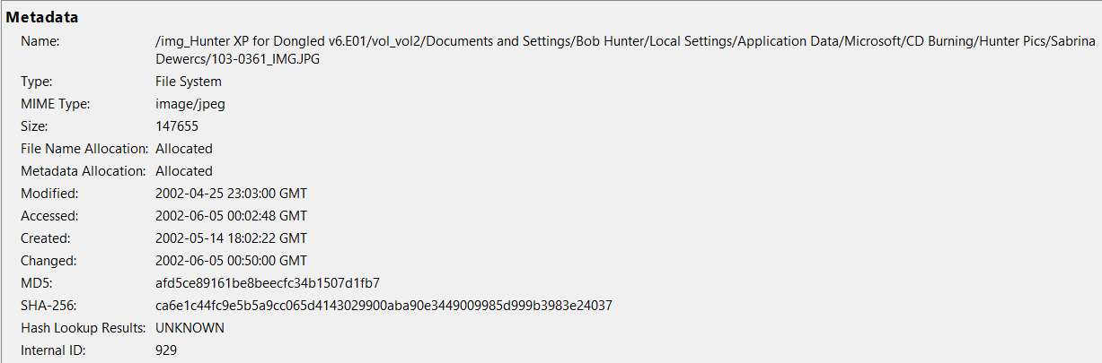
- Fig 4.3.5: Image from RECYCLER
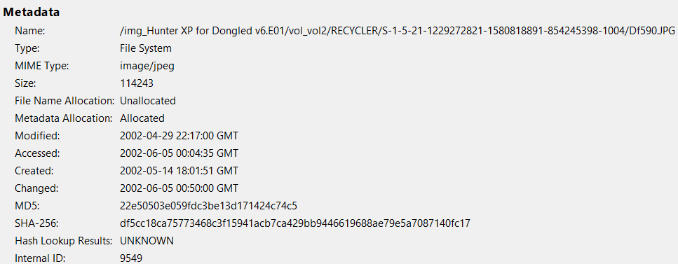
- Fig:4.3.6: Image from RECYCLER
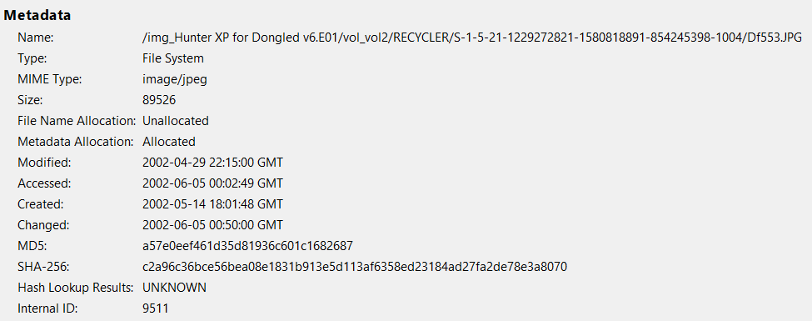
- Fig:4.4.3 : Login page of Xdrive
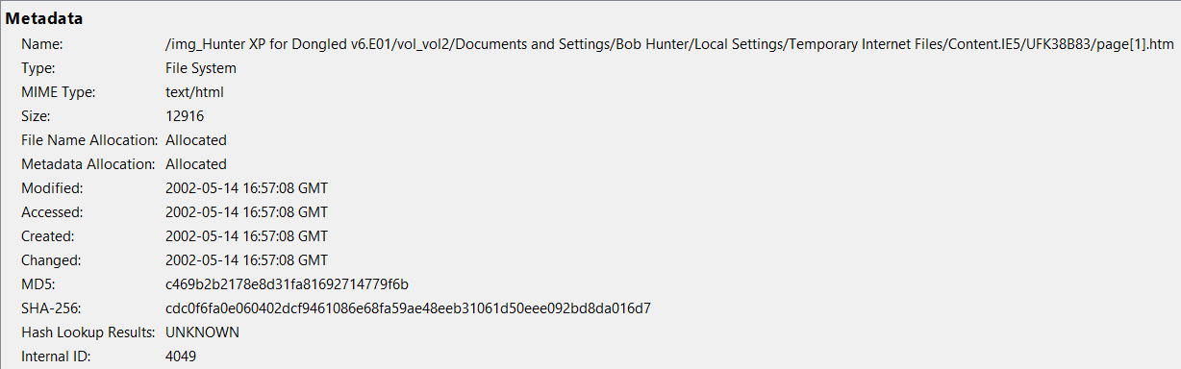

- Fig:4.4.4 : Criminal Defense Lawyers website
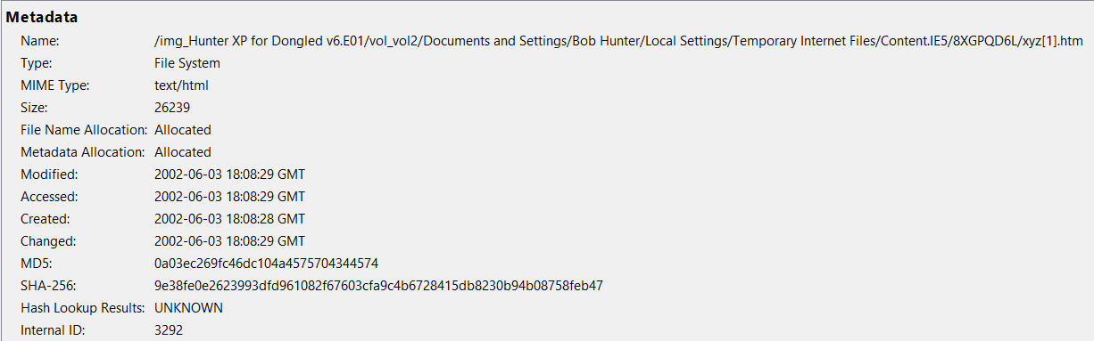

- Fig:4.5.1 : Conversation between Bob and Billy
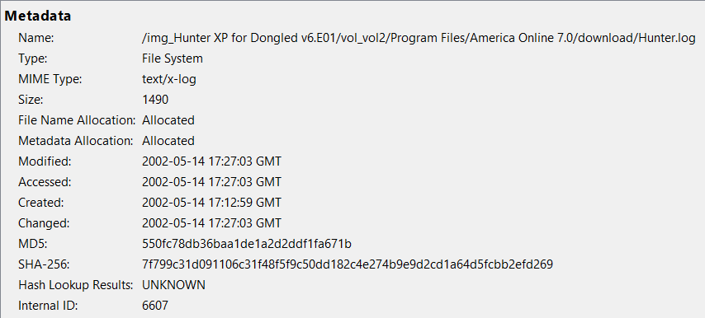
- Fig:4.5.2: Email addresses of victim’s father
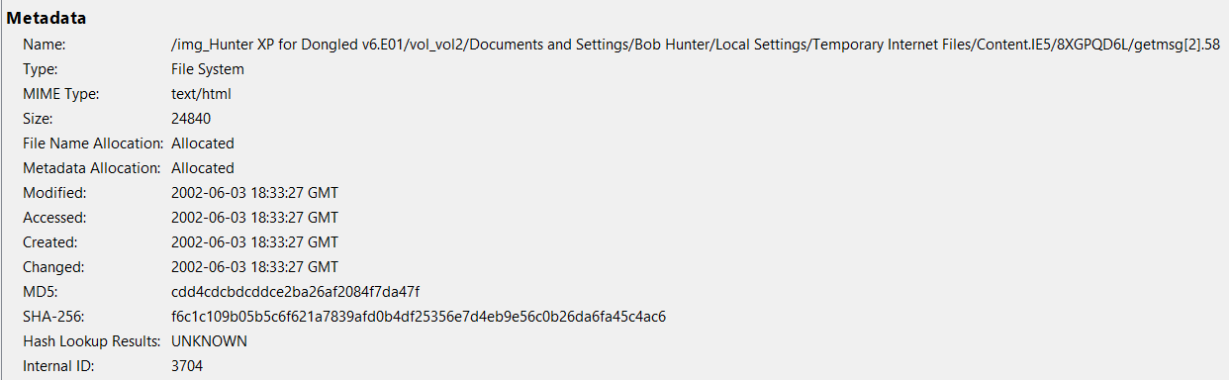

- Fig:4.5.3: Threating message sent to the victim’s father
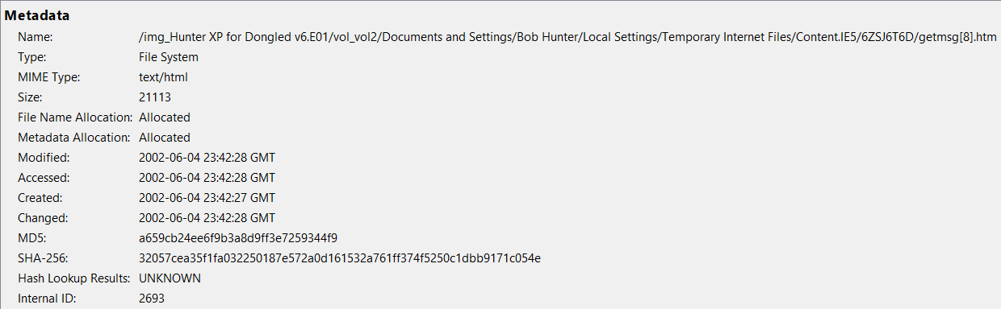

- Fig:4.5.4: Blackmailing
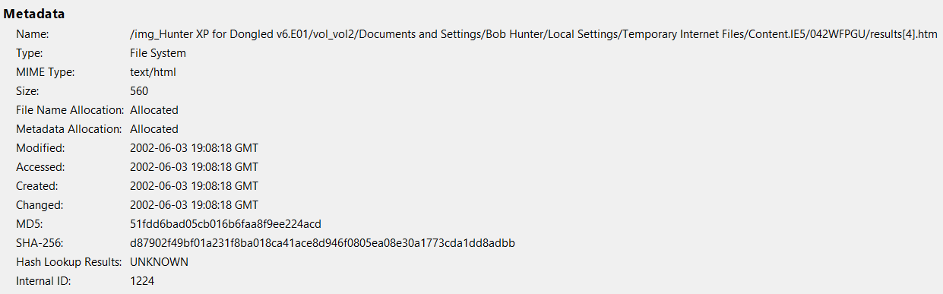

- Fig:4.5.5 : Bank information asked by the Bob Hunter to victim’s father
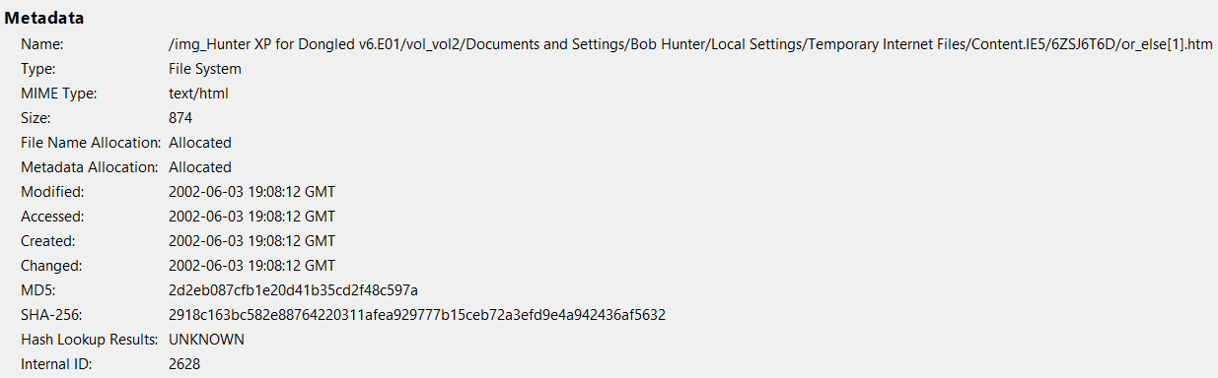

- Fig:4.5.6 : Reply of Ted Dewercs
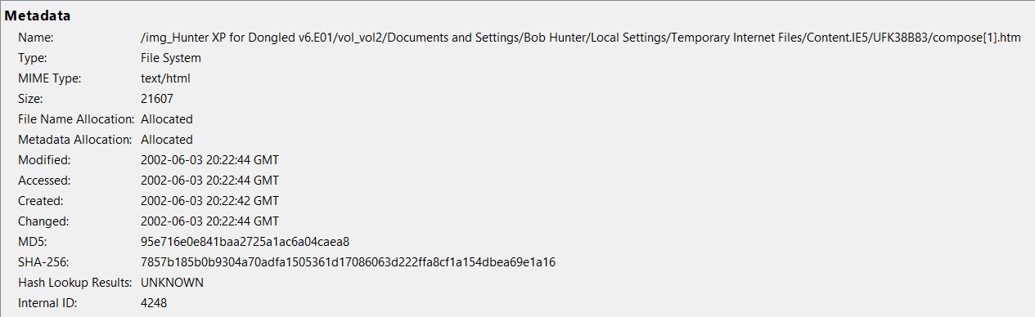

- Fig:4.5.7 : Reply of John Detsiwt
